ACCESSIBILITY

At ArcTanGent we believe that music and festivals should be accessible to all. Our accessible facilities are available for use by anyone with a disability, visible or invisible, inclusive of customers, performers and staff.

If you have a specific requirement that is not covered on this page, please get in touch by emailing access@arctangent.co.uk.

Register for Accessible Facilities at ATG 2026
To request use of our accessible facilities, including requesting Personal Assistant/Essential Companion tickets, please let us know by filling out an Access Request Form.

Link to the 2026 Access Request Form:
https://arctangent.festivalpro.com/form/jUaflzefYSJogJkbVJWn/0

This form will be open until 23:45 on the 6th of August, unless we reach capacity before this date. If you are looking to apply after this time, please email the Accessibility Team using the contact details below.

If you require the form in an alternative format, such as Large Text or Easy Read, please contact us and we will endeavour to provide your requested format within 10 working days.

Contact Details
By Email:
To speak to a member of our Accessibility Team, email access@arctangent.co.uk.

We aim to respond within 5 working days. Closer to the festival, response times may be longer, but we will endeavour to get back to you as quickly as possible.

By Telephone:
We do not have a company telephone number. To speak to someone over the phone, please email access@arctangent.co.uk with your phone number to request a callback. You may also include a preferred date and time.

Site Description
ArcTanGent is held on a working farm. The site has some gentle slopes, and the ground will be uneven at times. There are some hard-standing roads on the site, however, these are farm tracks and will likely be uneven with pieces of rubble and gravel.

Most areas are only accessible by crossing grass. In very dry conditions, the ground can become very firm and pitted, which can be uncomfortable for those using a wheelchair or mobility scooter. In wet conditions the ground can become very muddy and slippery.

Whilst each stage is covered, in the event of bad weather some site locations may become difficult to travel to. We will do our best to mitigate this, but we ask you to consider what additional equipment you may need in these circumstances and always check the weather forecast.

The following information is accurate for our 2025 event, and is subject to change for 2026:

Accessibility Map 2025:
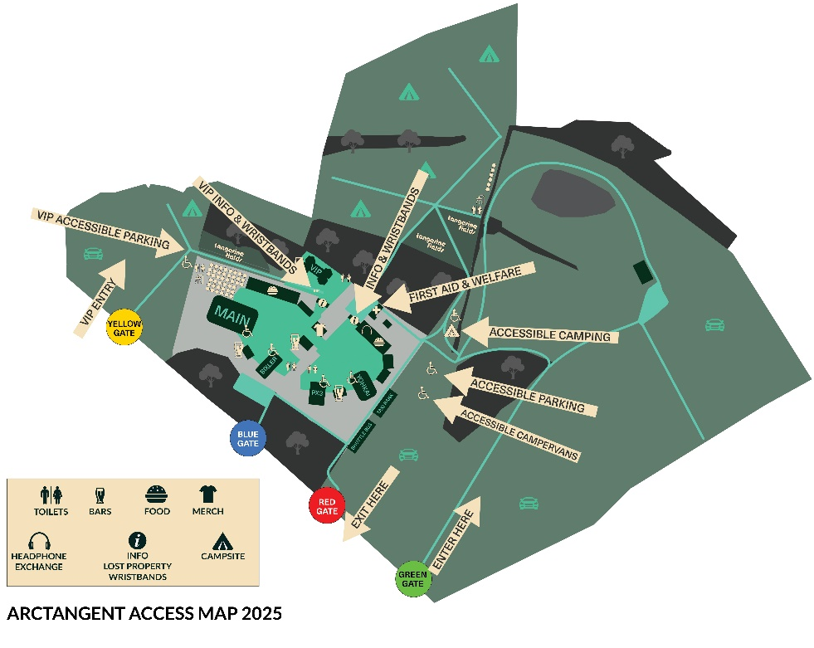
2025 Distances:
Accessible Car Park to Accessible Campsite = 50-100m
Accessible Car Park to Arena Entrance = 150m
Accessible Campsite to Arena Entrance = 150m
Accessible Live-In Vehicles to Arena Entrance = 200m
Taxi Rank to Arena Entrance = 250m
Coach Point to Arena Entrance = 265m

Bookable Accessible Facilities
Use of the following accessible facilities can be requested through our Access Request Form. Please purchase your required tickets (minus the personal assistant ticket if you require this) before filling this out.

Free Personal Assistant Tickets:
We offer a free Personal Assistant ticket to anyone who could not attend the festival without the assistance of another.

To be eligible for a PA ticket, you will be asked to provide evidence when completing the form. Accepted documentation includes:
- Disability Living allowance (DLA)/Attendance Allowance (AA) letter
- Personal Independence Payment (PIP) letter
- Valid Blue Badge (both sides)
- Valid Access Card
- Recognised Assistance Dog ID Card
- Evidence of being registered as severely sight impaired (blind)

If you don’t have documentation:
Each application is reviewed on a case-by-case basis. If you do not have documentation, you can use the ‘Alternative Statement’ option on your application to state why you require these.

Duties a PA may be expected to perform:
- Providing physical assistance
- Communication support, e.g., BSL interpreting
- Personal care tasks
- Ensuring safety and wellbeing
- Assistance in accessing facilities
- Facilitating enjoyment
A Personal Assistant would not be expected to perform roles such as medical decision-making, personal security, or assist another individual other than the customer they are supporting.

Accessible Parking:
Accessible parking spaces are free of charge and can be requested through your Access Request Form. On event days, space are filled on a first-come, first-served basis.

If you have not applied for accessible provisions but are a Blue Badge holder, please show this to stewards on arrival.

Pick-Up and Drop Off:
Accessibility customers arriving by Taxi or drop-off are welcome to drop-off and pick-up from the Accessible Car Park by temporarily occupying a space.

Accessible Campsite:
The Accessible Campsite is a dedicated camping area with additional accessible facilities and is quieter than the general campsites. There is limited space in this campsite, so please let us know if you need to use this.

To ensure we can accommodate as many people as possible, there is a maximum group size of 6 people in the Accessible Campsite.

Accessible Campervans:
Accessible Campervans are pitched in the first row of the General Campervans, directly behind the Accessible Car Park.

We have limited space for campervans, so please ensure you have informed us on your application. If you have already submitted your form but have changed your accommodation choice, please email access@arctangent.co.uk so we can review and update this.

Accessible Viewing Platforms:
We have an accessible viewing platform at each of our stages, which are stewarded during performance times.

We provide a small number of chairs on the platforms, but you are welcome to bring your own camping chairs onto the platform.

To use the viewing platforms, you will need to show your Viewing Platform Wristband. You will also be issued a lanyard to allow one other person to join you on the platform, e.g., your PA or a companion.

Accessible Toilets:
Accessible toilet facilities are available at each viewing platform in the Arena, as well as within the Accessible Campsite and other public campsites.

All accessible toilets will portaloo units. You do not need a radar key to use these.

Charging for Mobility Aids and Assistive Equipment:
Charging facilities for mobility aids and assistive equipment is available at Festival Reception. Please bring your own charging cables. You may also wish to label your equipment with your name and contact details.

Please note: We do not offer medication storage or refrigeration services.

Travel Guide
Festival Address: Fernhill Farm, Compton Martin, BS40 6LD

Green Gate – Main Car Park entrance for everyone except VIPs / bands / staff
Red Gate – Exit only
Yellow Gate – VIP Car Park Entrance

By Car:
Please navigate to the address provided above, then follow directional signage to the relevant entrance gate, depending on your ticket type. Stewards will then direct you to a space. Entrance gates are also marked on Google Maps.

By Taxi or Drop-Off:
If you are coming by taxi or drop-off, ask the driver to navigate to GREEN GATE and follow along the track to the Taxi Rank.

Accessibility customers arriving by Taxi or drop-off are welcome to drop-off and pick-up from the Accessible Car Park by temporarily occupying a parking space.

A list of local accessible taxis can be found on the Bristol City Council website. Please enquire directly to book your travel, we recommend pre-booking as signal can be poor.

By Coach:
Our official travel provider is Tuned In Travel, providing National Coaches, a regular Bristol Coach Service, Shuttle Tickets, and Private Hire.

For accessibility enquiries, please email your specific requirements to customerservices@tunedintravel.com and they will confirm if they can supply a coach to meet your needs.

By Train:
The nearest train station to the festival site is Bristol Temple Meads. Find out more information about accessibility at this station on the Great Western Rail website.

Arrival Guide
If you are camping, first set up in your campsite, then head to Festival Reception. If you are using the Accessible Campsite and need any assistance, please ask a member of staff for support.

Day ticket holders, head straight to Festival Reception.

At Festival Reception, use the Accessible Lane to get your tickets scanned and receive your wristbands and accessibility passes.

Medical and Welfare Services
We have 24-hour Medical and Welfare services available on site at ArcTanGent.

We treat medical cannabis (oil and/or flower) like any other medication. As our security personnel conduct spot checks for recreational cannabis, we kindly ask you to store this in a clearly labelled bag and carry a copy of your prescription with you.

Please Note: We are currently unable to provide medical refrigeration or storage services on site.

Access to Performance
Currently, we do not provide British Sign Language (BSL) / Captioning / Audio Description.

Assistance Dogs
Assistance dogs are welcome at ArcTanGent. So that we can provide the necessary facilities, we kindly ask you to let us know if you are planning to bring an assistance dog with you to the event on your Access Request Form.

We do not have a dedicated Spending Area. Please use an area near any toilet block and place waste in a nearby general waste bin.

Sensory Information
ArcTanGent showcases many genres that would be considered ‘heavy’ and involve more intense lighting displays. You are likely to feel the music through the ground and in your chest.

We do not have a Sensory Calm Space, however our Welfare team are available to provide respite for anyone feeling overwhelmed or in need of assistance here.

Strobe Lighting and Visual Effects
Strobe lighting may be used in any of our performances throughout the weekend and will not be announced prior. The genres showcased at ArcTanGent tend to use strobe lighting frequently, so please prepare if you might be affected by this.

Other visual and sound effects may also be used across all performances.

Other Information
Closer to the event, we will be sending out a more detailed Accessibility Information Pack. Please get in touch with access@arctangent.co.uk if this is something you wish to receive.

